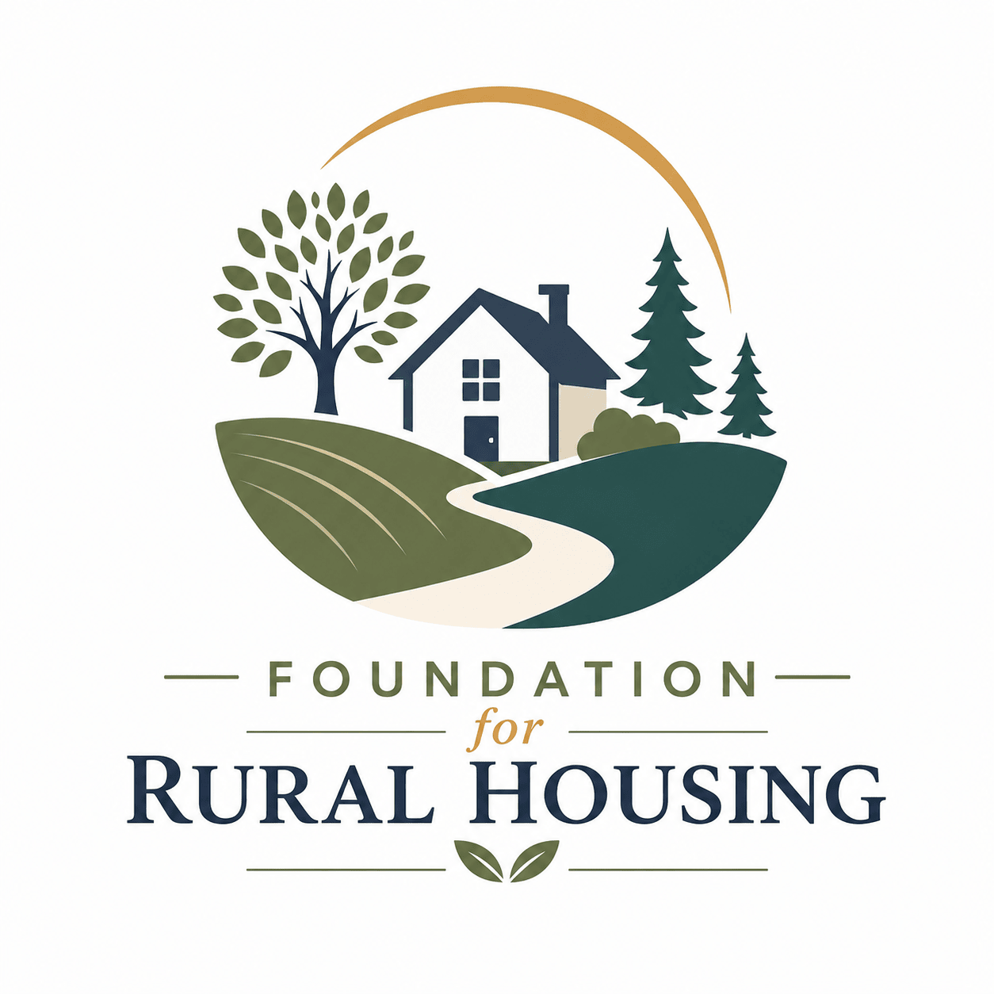
Job Title: Program Director – NE Region Expansion
Foundation for Rural Housing, Inc. NE Region Starting Salary $55,000
www.ffrh.org
Type: Full-Time Office location will be 3500 Packland Drive, De Pere Wisconsin

Foundation for Rural Housing is opening an office in the Northeast region of Wisconsin with office location around De Pere, Wisconsin. We are a Community Action program whose mission is to help low- and moderate-income households reduce barriers and empower their success to become financial independent. We have been providing housing assistance services in this region for the past 20 years and will now build a permanent office location within the 10-county region.
We are looking for an entrepreneurial, operations-minded Program Director to work alongside the Executive Director to launch this office—building strategic partnerships and establishing our presence in the market.

The Opportunity
As Program Director, you will own the end-to-end execution of our strategic roadmap. You will act as a community advocate, listening to the needs of low to moderate income households, help expand existing programs and assist with the development of new programming.

Key Responsibilities
- Partnership Development: Identify, cultivate, and secure relationships with key local stakeholders, corporate sponsors, community leaders, and regulatory bodies. Participate in community events.
- Operations & Delivery: Oversee day-to-day operations during the expansion phase, ensuring programs meet quality standards, compliance requirements, and performance benchmarks.
- Impact Tracking: Monitor goals and outcomes with CRM system for year-end reporting
- Supervising: Supervise program staff to ensure programs and services goals are being met
Experience we are looking for:
- 5 plus years’ nonprofit experience, specifically with working with community partners and administering programs
- 5 plus years working with data collection and reporting oversight responsibilities
- Experience working closely with community partners and serving those that need direct services
- Microsoft office products knowledge
- ZOHO or CRM platform knowledge such as salesforce plus or other IT help desk experience
- HUD Certified Counselor a plus

What We Offer
- Benefits: IRA contribution 8% of annual salary, PTO, hybrid telework position after 9-0 days of employment. We do not offer Health or Dental Insurance.
- Impact & Autonomy: High ownership of a brand-new region with direct access to executive support.

How to Apply
Submit your resume along with a brief cover letter outlining a time you successfully launched a program, scaled a location, or built an initiative from the ground up in a new market. Email this to Jenny@ffrh.org. We anticipate a end of September early October start date.

